When volunteering, it's important to dress appropriately for the task at hand.
Here are some general rules to follow when choosing your volunteer outfit:
Dress for the occasion
Consider the role you are going to be doing- Will you be inside or outside? In a kitchen with staining potential?
Keep it comfortable
Make sure your clothes and shoes are comfortable. Things like itchy tags and tight shoes can make your day a lot harder.
Dress for the weather
Consider the weather when selecting your outfit- is it hot and sunny, or cold and raining?
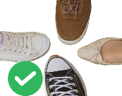 | Proper Shoes  Your shoes should be enclosed
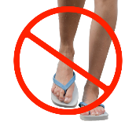 | Thongs, bare feet, and sandals may not be allowed
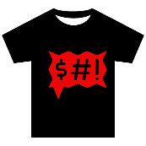 | Your clothing should not be too low cut, or contain any nudity, swearing, or offensive words or pictures.
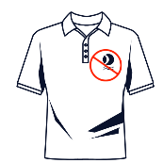 | Try and void branding and logos that aren’t the organisation you volunteer for.
 | Make sure your clothes are clean and do not have any rips or stains.
If you have questions, ask.
Most organisations will have rule around what you can wear, and if you have any questions, ask your supervisor.

