Accessible Communication in Social Media Posts
- Use clear and descriptive language: Avoid using slang, jargon or acronyms that may be confusing or difficult to understand. Additionally, provide as much detail as possible in your post so that all readers can understand the message you are trying to convey.
- Fonts and size matter: Use a sans serif font (ones without flourishes and lines like Times New Roman) opt for Arial, or Calibri if you are unsure. Font size should be a minimum of 12pts to ensure readability for people with low vision.
- Avoid Excessive Emojis: When read by a screen reader, emojis can be confusing, especially when you have multiple in a row. Make sure the emojis are used sparingly and add to the context or post.
- Add alternative text to images: Alternative text (alt text) is a brief description of a picture that is read aloud by screen readers for users who are visually impaired. Make sure to include alt text for all images in your social media posts, including memes and GIFs. You can add these to the end of the post, or to the image itself, or both. We have a guide on Adding Alt text that you can access here
- Use contrasting colours: When designing your social media post, make sure to use colours that contrast well with each other. This will make it easier for users with colour blindness or other visual impairments to read your post. You can check the contrast by googling free contrast checker, which will tell you. If in doubt, use a very light background and a very dark text.
- Use closed captions for videos: If you are sharing a video on social media, be sure to include closed captions. This will allow users who are deaf or hard of hearing to follow along with the video's content.
- Use camel case for hashtags: Camel Case is when you capitalise each word in a hashtag, which makes it easier to read, including people using screen readers.
For example, instead of #volunteeringisfun, use #VolunteeringIsFun.
- Links and Hashtags at the end of the post: Links and hashtags are hard for screen readers and can get confusing in the middle of a post. Also avoid using just “click here” as people using a screen reader will not be able to access. By adding “click here or the link below”, you immediately make the post more accessible.
- Provide transcripts for audio content: If you are sharing audio content on social media, such as a podcast episode, provide a transcript of the content. This will allow users who are deaf or hard of hearing to follow along with the content.
- Avoid flashing or animated content: Flashing or animated content can trigger seizures in some users with epilepsy. To ensure your social media post is accessible to all users, avoid using flashing animated content, or words quickly fading in and out

Accessible Social Media Checklist
Used Clear and Descriptive Language
Used a Sans Serif font, Minimum 12pts (e.g. Arial or Calibri)
Sparing use of Emojis to add context
Added Alt text to image, or Image description at end of post or both
Used Contrasting colours
Used Closed Captions on Video content
Used Camel Case on Hashtags
Links and Hashtags at the bottom of the post
Transcripts available for audio content
No flashing or animated content, or pre-warning included

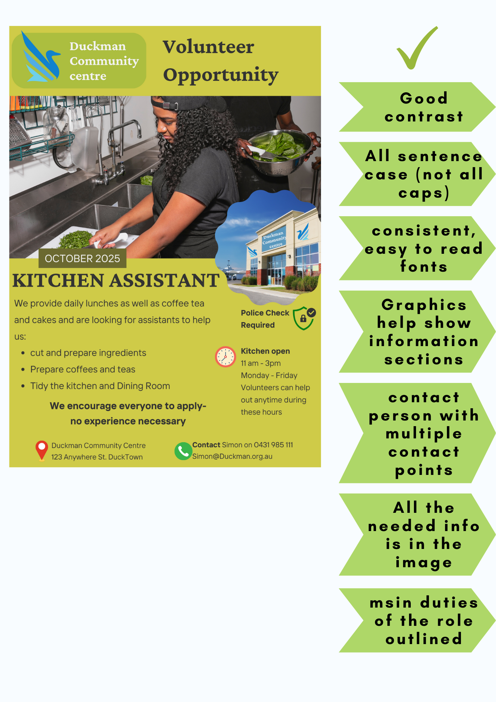
Example flyer image
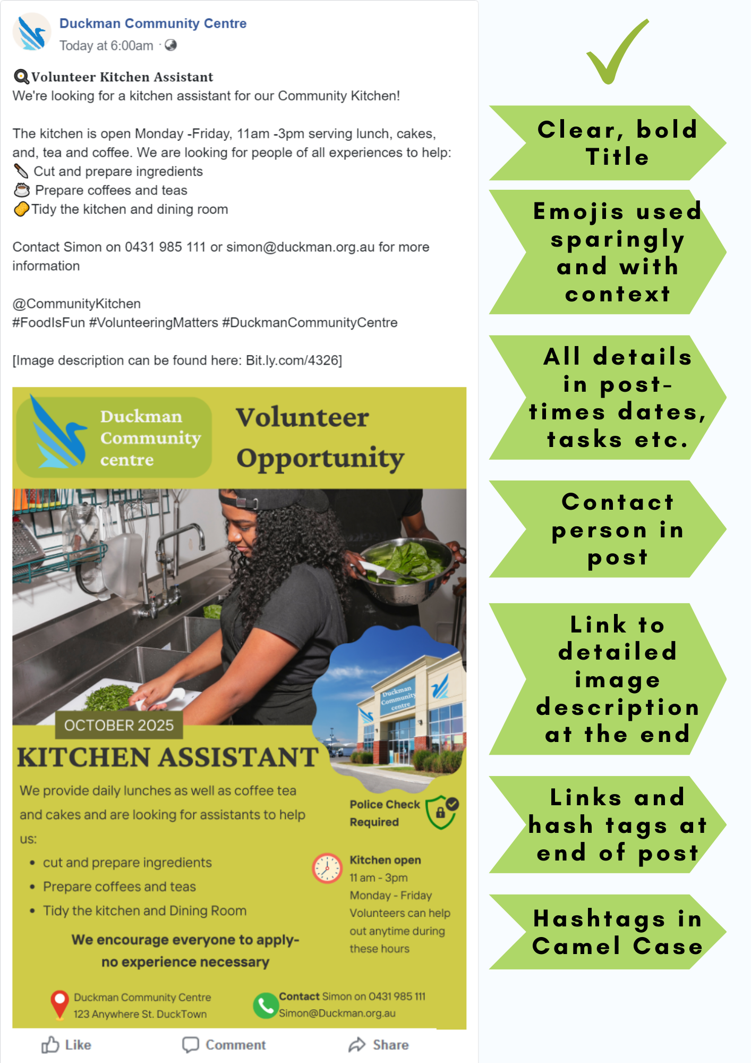
Example post with flyer

